**Lesson 07 Lesson-End Project**

**Create and Configure Groups and Users Using Policies**

**Project agenda:** To demonstrate how to use AWS IAM to create and configure groups and users with different policies and permissions

**Description:** The admin of a corporation wants to create three groups of IAM users, each with two users and two policies assigned to them. The policies will define the permissions and roles for the users to perform their tasks in their respective groups.

**Tools required:** AWS

**Prerequisites:** None

**Expected deliverables:** One of the three groups must be able to operate using CLI commands without accessing the AWS console

Steps to be followed:

1. Create a group
2. Configure the user for CLI operation

**Step 1:** **Create a group**

1. Navigate to the AWS Management Console, search for and select **IAM**

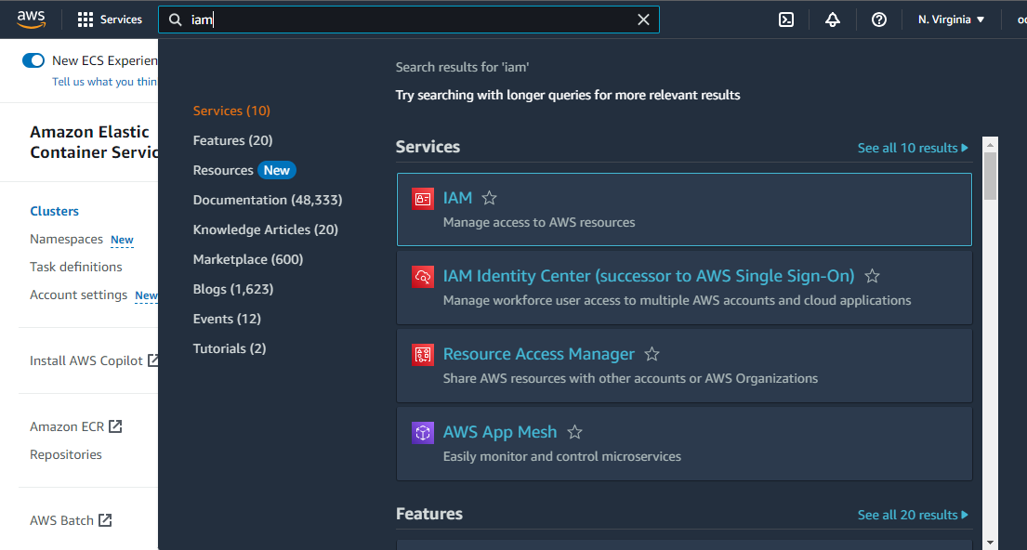

1. Click on **User groups** > **Create group**

1. Enter the user group name as **Groups1**

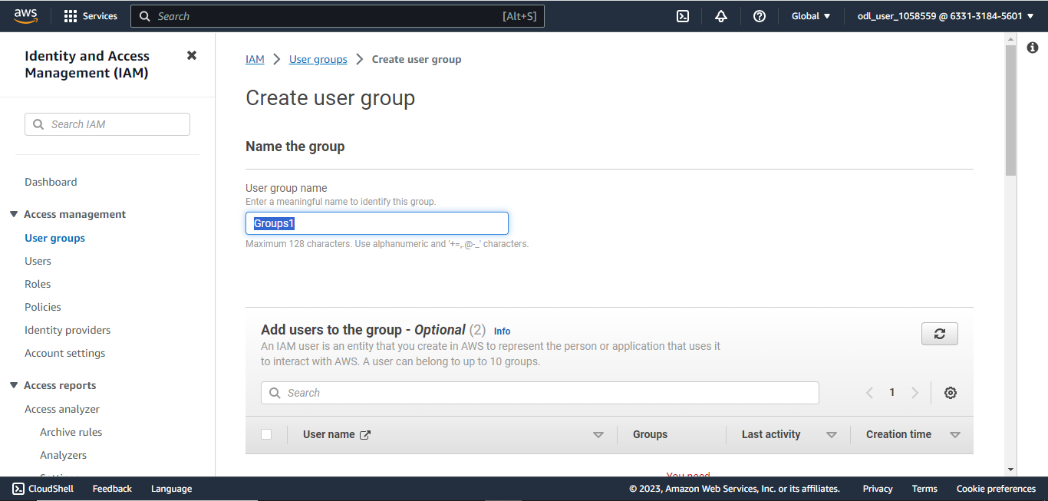

1. In the **Attach permissions policies** section, search for and select the following policy:

1. Click on the **Create group** button

The group **Groups1** is created successfully.

1. Follow the same procedure to create **Groups2** and **Groups3**

1. In the **IAM** dashboard, click on **Users**, and then click on **Create user**

1. Enter the user name as **user1_Groups1,** and select the **Provide user access to the AWS Management Console** checkbox. Then click **Next**.

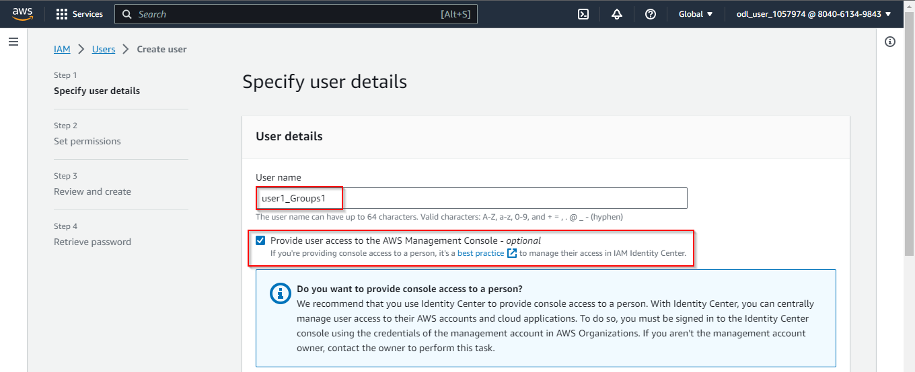

1. In the **Add user to group** section, select **Groups1** and click **Next**

1. Click on the **Create user** button

1. Download the **.csv** file, and then click on **Close**

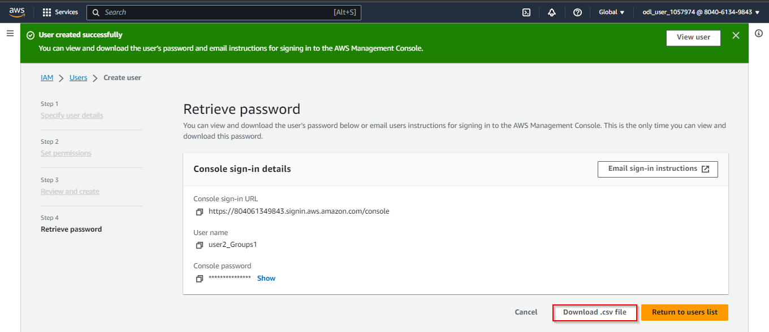

1. Create five more users, and assign them to their respective groups following the above

procedure

1. Select any user and click on **Create access key**

1. Click on **Command Line Interface (CLI),** and then click **Next**

1. Enter any description tag value, and click on **Create access key**

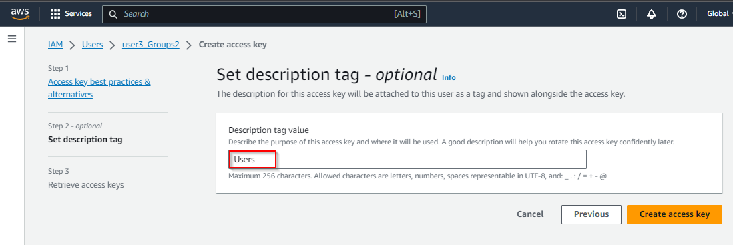

The Access key is created successfully.

**Step 2: Configure the user for CLI operation**

1. In the AWS dashboard, search for and select **CloudShell**

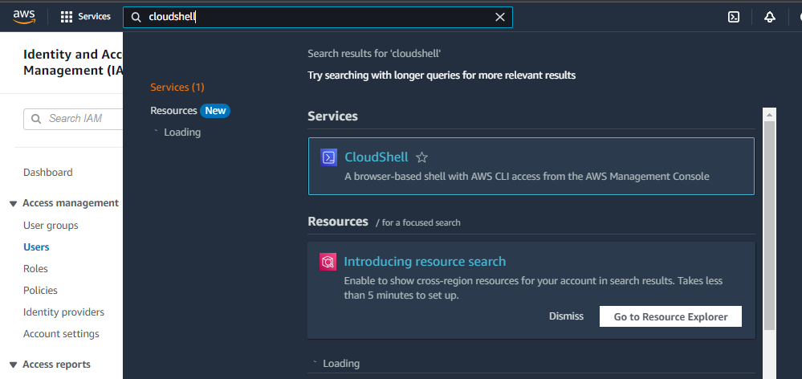

1. Click on **Create access key**

1. In CloudShell, enter the following command:

**aws configure**

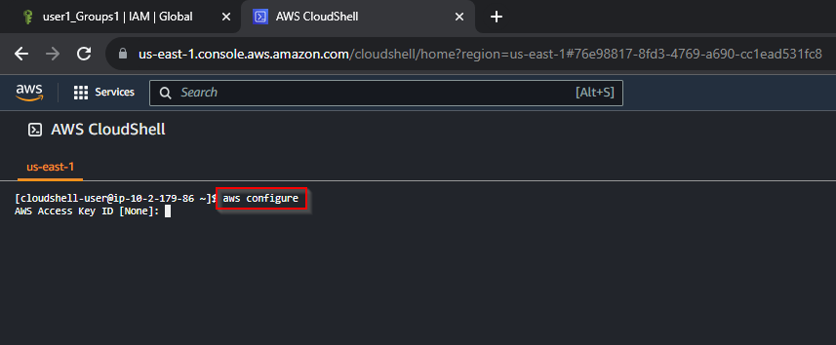

1. Open the downloaded **.csv** file, and copy-paste the Access Key ID and Secret Access Key into the terminal

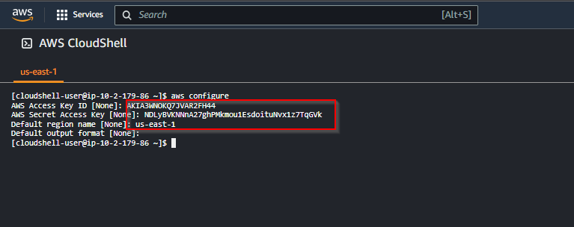

The user is configured successfully for CLI operation.

By following these steps, you have successfully demonstrated how to use AWS IAM to create and configure groups and users with different policies and permissions.